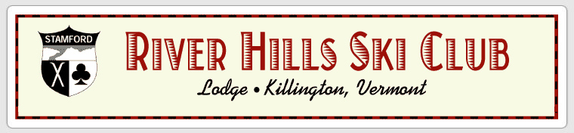

Board Meeting February 14, 2013
Meeting held at Lori Constantine’s house

Completed by: Lori Constantine
Phone Number: 203-359-8607

Attendees Board Members

Name Position
John Olshan President
Stephanie Evers Vice President
Kyle Eberts Assistant Treasurer
Lori Constantine Secretary
Beth Cross Membership
Heather Lopresti Activities

Decisions Made:
- Prorate membership dues for new members for the remainder of 2012 – 2013 ski season
- Eliminate voucher requirement for the remainder of the 2012- 2013 ski season
- Schedule an additional Meet and Greet social for guests who found RHSC on Meetup at the Long Ridge Tavern
- Waive half the weekend lodge fee for members who attend Snow Carnival
- Profits from Summer Olympics lodge fees to go to the game room update

Recap To Dos:
- Publish Treasurer’s Report by 2/18
- Lori to discus updating the Game Room with Tom Constantine
- Anne Z to send Beth H list of Meet & Greet attendees
- Heather to draft and email blast about Snow Carnival
- Confirm date for Spring Fling May 18, June 1st or 8th –
- Confirm date for Summer Olympics at the Lodge –July 19 – 21
- Send a reminder blast about summer weekend buy out
- Beth to investigate Master Lock Box
- Curtis to provide an accounting of all keys

Details & Discussion:

Treasurer’s Report -
- Board is very concerned about failure to provide Treasurer’s Report
- Stephanie working with Tom to have Treasurer’s Report by Monday, Feb 18
- Kyle and John to provide support as requested
- Beth to provide membership info (dues, DMF, bin rentals) to Stephanie

Membership report-
- Discussion on prorating the dues & eliminate the voucher for new members who join (vouchers were intended to enhance cash flow in the beginning of the season and encourage usage of the lodge).
- Board voted unanimously to prorate the membership dues
- Board voted 2 no & 3 yes to eliminate voucher requirement for the remainder of the 2013 ski season.
- 30 invited to Meet & Greet. 5 attended. Beth to send email to Anne Z. requesting list of attendees to follow up with
- Rules for guests are that guests cannot stay at the lodge without a sponsor. Sponsor must be staying at the lodge while the guest is staying at the lodge.
- We should schedule another Meet & Greet at the LRT. Let’s target a week night in early March. We’ll consider attending the Meet & Greet attending a meeting for members.

Discussion around request to renovate the game room. The board loves this idea! However, we don’t have the money at this time. Options to make this happen are:
- Next board build the cost into the DMF (kind of an assessment)
- Assess the membership
- Have kids run a fundraiser

To spend more than $1,000 requires a vote of the membership. The DMF is really there for upkeep/maintenance and basic improvements. So – we’d like for the parents of kids to help them:

- Raise the money
- Solicit donations

DMF funds cans be used to paint and spruce-up the Game Room during the work weekend.

Meet & Greet for MeetUp
- 5 people attended the Meet & Greet at the Long Ridge Tavern
- The attendees seemed like good fits
- One stayed the weekend at the lodge
- All attendees signed in
- We need to follow up with the attendees. Anne & Beth reach out to Anne for contact info & any other potential members

Activities/Programs
- CSC on Snow Carnival -vote to waive lodge fees for members who attend CSC on-snow events at Okemo, March 1st & 2nd. We’ll waive half the weekend fee for members who attend Snow Carnival. Heather to draft and email blast.
- Spring Fling May 18, June 1st or 8th – dates to be confirmed
- Summer Olympics at the Lodge –July 19 - 21 Tents in the yard for overflow? dates to be confirmed
- Board voted on & approved proceeds to go to improving the game room
- Send a reminder blast about weekend buy out

Operations
- We need to have a few back up keys.
- Traps need to be reset or removed.
- We need a lock box with a master code. Beth to investigate Master Lock Box
- Curtis to provide an accounting of all keys

What is a quorum? We need to revisit/revamp the board members. Should we add a Technology board member?
John asked Mike Kellick to chair the 2013-2014 board nominating committee. Mike agreed.

- Next Board Meeting March 4th

- Next General Meeting March 12^{h}

